NATWA II 2018 Convention
“Face Challenges, Live Better”
LAX Renaissance Hotel
Tentative Itinerary

Friday, April 20, 2018
7:30 – 8:30 PM Ice-Breakers
9:00 PM – ??? Night Out on the Town

Saturday, April 21, 2018
10:00 AM – 2:00 PM Sightseeing/Lunch in Los Angeles
3:00 – 5:00 PM “Healthy Body, Healthy Mind” Workshop (Syd Yang)
5:00 – 6:00 PM NATWA II Planning Session
7:00 PM – ??? Dinner Out on the Town

Sunday, April 22, 2018
9:00 – 10:30 AM Taiwanese & Taiwanese-American Filmmakers: Sharing Stories of Parent-Daughter Relationships
(Jessie Lee, Mian Mian Lu, Remii Huang)
10:30 – 11:00 AM Closing Ceremony

YOU MUST REGISTER FOR THE NATWA CONVENTION IN ORDER TO ATTEND ANY OF THE EVENTS AT THE CONVENTION. PLEASE ALSO EMAIL NATWA II AT natwa2@gmail.com TO LET US KNOW YOU WILL ATTEND.

NATWA Convention Registration
Please complete and mail the attached registration form
March 17, 2018 or earlier: $15
March 18 or later: $20

NATWA II Confirmation
Please email natwa2@gmail.com

Accommodations:
Renaissance L.A. Airport Hotel
9620 Airport Blvd., Los Angeles, CA 90045-5402
310-337-2800 or 800-468-3571

Hotel Reservation:
Last day to book: March 30th, 2018
NATWA Group Rate: $129.00/per night Code: NAT
Free Shuttle Service

4/21/2018 Saturday Workshop:
“Healthy Body, Healthy Mind”

Health is so much more than just numbers or a diagnosis. It is often rooted in our feelings and experiences as we move through the world. To be healthy is to access wellness on a regular basis. How can we cultivate more health, wellness and joy in our bodies, individually and collectively? This workshop will be an interactive and creative space to learn, share and engage our wellness in new ways.

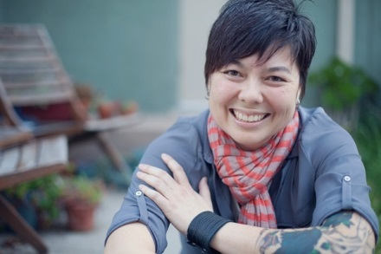
Stephanie Syd Yang is a mixed race, 2nd gen Taiwanese American queer writer, energy healer and spiritual coach who supports individuals and small groups through her practice, Blue Jaguar Healing Arts. She facilitates spaces for folks to access health and wellness that is culturally and spiritually rooted. Her work locates its resonance at the intersections of memory, body, sexuality and mental health. One of her short stories can be found in the upcoming Taiwanese-American anthology, Chrysanthemum. More at bluejaguarlove.com.

4/22/2018 Sunday Panel: Taiwanese & Taiwanese-American Filmmakers: Sharing Stories of Parent-Daughter Relationships

This panel will present three short films by Taiwanese and Taiwanese-American women filmmakers who were featured at last year's inaugural Taiwanese American Film Festival. The films share stories of young women and their parents in three very different styles. After the video presentations, Jessie Lee, director of audience-award winner "Never Let You Go," will join us in person. Remii Huang, director of "Color Positive," will join via Skype video call. Mian Mian Lu, director of audience-award winner "My Mom's Wedding," is based in Taiwan so she will tell her own story via a short video.

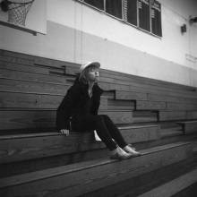
Ms. Remii Huang is a Taiwanese American director who has been involved in over a dozen music videos and commercials., “Never Let You Go,” a short film she directed was featured during the first Taiwanese American Film Festival in 2017. She is looking forward to sharing her thoughts regarding this project by virtually joining the Sunday morning NATWA panel via Skype. Please feel free to browse her website to see more of her work: https://www.remiihuang.com/

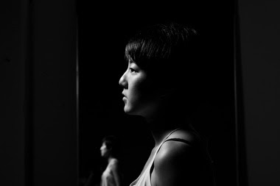
Jessie Lee was born in Baton Rouge, Louisiana, and on the other side of the world in Taiwan. She majored in film studies an literary journalism at the University of California, Irvine, before freelancing as an assistant camera on set as well as working as an assistant editor at a trailer house in Los Angeles. Jessie is currently a MFA film directing student at UCLA. Her work resolves around themes of displacement. She tells stories of characters that have been uprooted or struggle to find a sense of cultural belonging in their environment.

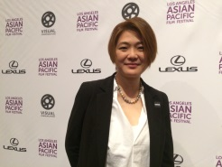
Mian Mian Lu was born in Taipei, Taiwan in 1976. She began living on her own at as a teenager, and became involved in Taipei’s avant-garde theater scene. She wrote, directed and starred in plays. She was a member of Critical Point Theater in Taiwan, and in 1996 founded The Door Theater. From 2008 until 2012, she lived in Brooklyn, New York, where she made short films and directed a small-theater piece for the Brick Theater. She moved back to Taipei in 2012. Her short film MIDNIGHT DANCE was screened at Asian American International Film Festival and Los Angeles Asian Pacific Film Festival. Her latest short film MY MOM’S WEDDING received a special award from Women Make Waves Film Festival Taiwan. She is preparing her first feature film “Mickey on the Road”.
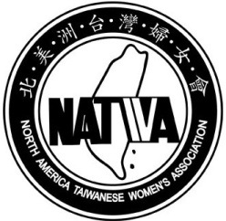
北 美 洲 台 灣 婦 女 會
North America Taiwanese Women’s Association

NATWA Annual Meeting
April 19-22, 2018
Renaissance Los Angeles Airport Hotel
主題:活出美好，面對挑戰 “Face Challenges, Live Better.”
Date | 4/20/18 | 4/21/18 | 4/22/18
Day of the Week | 星期五 Friday | 星期六 Saturday | 星期日  Sunday
自由活動 | 7:00am - 7:50am  瑜珈 Morning Exercise
7:00am - 8:45am
早餐Buffet Breakfast
 | 8:50am - 12:00pm  Board Meeting, Reports, and Proposals  會員大會  Spouse 節目 | 8:50am - 10:30am  我的主持之路  李晶玉 | 9:00am-10:30am  Film Makers  NATWA II
 |  | 10:45am - 12:00pm  衝突的藝術 | 10:30am-11:00am  Closing Ceremony
 | 12:15 pm - 1:30 pm  午餐 Buffet Lunch |  | 4/22 下午-4/25會後旅遊四天三夜開始  *******************  Las Vegas, Zion National Park, 包偉湖, Glen Canyon, 馬蹄灣，上羚羊峽谷，Joshua Tree National Park.  Sedona.石中洞公園，水上賭城-拉芙琳，科囖拉多河遊船。日落火山口。 回程機票請訂4/25 8:30pm以後  名額有限，額滿截止。以收到支票為準。
 | 1:45pm - 3:00pm  如何與成年子女相處 | 1:45pm - 3:00pm  林文政
3:00pm-  開始報到Registration | 3:15pm -4:30pm  NATWA何去何從 | 3:15pm - 5:00pm  同心圓
4:30pm - 5:45pm
新生訓練
6:00 pm - 7:30 pm
晚餐 Plated Dinner
6:30pm - 9:30pm  理事會 | 7:45pm - 9:30pm NATWA Night | 7:45pm - 9:30pm  L.A. Night
7:00pm - 9:30pm  認親結緣  Ice Breaker | 9:30pm - 10:30pm  Social Time/Fun Time | 9:30pm - 10:30pm  Social Time/Fun Time

Questions?
Online Registration: 李淑嬪 Grace Chiou 626-581-7577 grace_chiou@yahoo.com
Mail Registration and Check: 蘇雅芬 Ya-fen Su 626-964-7569 psnewgarden@yahoo.com
Optional Post-meeting Tour: 翁淑鐶 Suzie Wang805-419-4755 suziewang999@yahoo.com
北 美 洲 台 灣 婦 女 會
North America Taiwanese Women’s Association
2018 年第三十屆婦女會年會

NATWA Annual Meeting
April 19-22, 2018
Renaissance Los Angeles Airport Hotel

Registration Form
On line registration: 請上NATWA 網站http://www.natwa.com 點選年會報名。

English Name (as in directory): __________________________ Taiwanese Name: _________________________
Are you a NATWA member? __Yes __No If yes, which chapter? ________ or which state? _________
Address: _______________________________City: _______________ State: _______ Zip Code:_________
Phone: ______________________E-Mail Address:_______________________________(for confirmation )
____Please check if your information in the directory needs to be updated.
Guest’s Name & Relationship: _______________________________Taiwanese Name: _______________
Name of roommate: __________________
(1) Registration Fee: A: NATWA member and family US$15/person $15 x __ = $____
B: Non-member US$45/person $45 x __ = $____

(2) Meal Plan: Please check here if Vegetarian Meals are required: ____
A: 4/19 (bento) 4/20~21 B, L, D 4/22 B US$295/person $295 x __ = $____
B: 4/20 -21 B, L, D 4/22 B US$280/person $280 x __ = $____
(3) 4/22-4/25 羚羊谷 （ 包三晚住宿，三晚餐，四中餐，三早餐，門票，
車費，小費，水，水果，點心） $499 x __ = $____
(4) 4/22-4/25 Sedona 鳳城 （包三晚住宿，三晚餐，二中餐，一早餐， $469 x__ = $____
叮噹車，逰船票，車費，小費，水）

(5) Late Charge Postmarked after 3/18/2018): US$20/person $20 x ___ = $ _____

Please make check payable to NATWA Total Amount Enclosed: US$ __________
Mail check to: NATWA Annual Meeting Registration
蘇雅芬 Ya-fen Su
1800 Paseo Azul, Rowland Heights, CA 91748 **報名截止日期: 3/30**
Cancellation Policy: Please notify Ya-fen Su 626-964-7569 psnewgarden@yahoo.com No refund after 3/30/18.
Emergency Contact Name & Relationship: _______________________________ Phone No:_________________
- Waiver form is signed and attached

NATWA Activity Waiver
I certify that I am physically fit for participation in this event and have not been advised otherwise by a qualified medical person.
I acknowledge that this Accident Waiver and Release of Liability (“AWRL”) form will be used by the North America Taiwanese Women’s Association (“NATWA”) and the sponsors of the event in which I may participate and it will govern my actions and responsibilities at said event.
In consideration of my application and permitting me to participate in this event, I hereby take action for myself as follows:
(A) Waive, release, and discharge NATWA, its directors, officers, volunteers, the event sponsors, and event volunteers (collectively, the “Released Parties”) from any and all liability for my death, disability, personal injury, property damage, property theft or actions of any kind which may hereafter accrue to me or my traveling to and from this event, (B) indemnify and hold harmless the Released Parties from any and all liabilities or claims made by other individuals or entities as a result of my actions during this event.
I hereby consent to receive medical treatment that may be deemed advisable in the event of injury, accident, and/or illness during this event.
I understand that at this event or related activities I may be photographed. I agree to allow my name, voice, and photo, video, or film likeness to be used for any legitimate purpose by the event holders, producers, sponsors, organizers, and/or assigns.
This AWRL shall be construed broadly to provide a release and waiver to the maximum extent permissible under the applicable law.
I hereby certify that I have read this document and I understand its content.

Print Name: ________________________________________________

Signature: __________________________________________________ Date: _______

